**Project- Quality Analysis Dashboard**

**Objective:**

The project aims to deliver products that fulfills customer expectations by identifying, designing, and controlling quality standards throughout the product lifecycle. This ensures customer satisfaction, minimizes defects, and enhances brand reputation.

I have used sample data to create this multi-page dashboard. This dashboard displays Total Task, Sample, Defect, Fatal Error, Quality Score, and all the aspects that resulted for the low-quality score.

Dashboard sheets

1. Sheet 1 – Overview

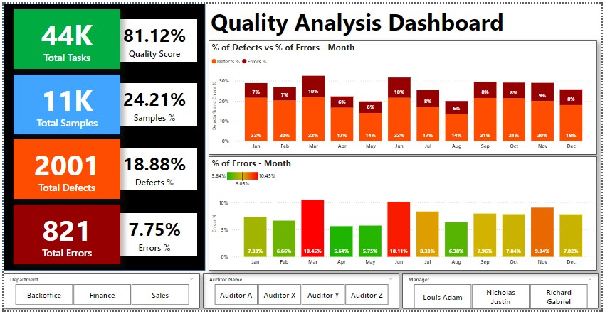

1. Sheet 2 – Details

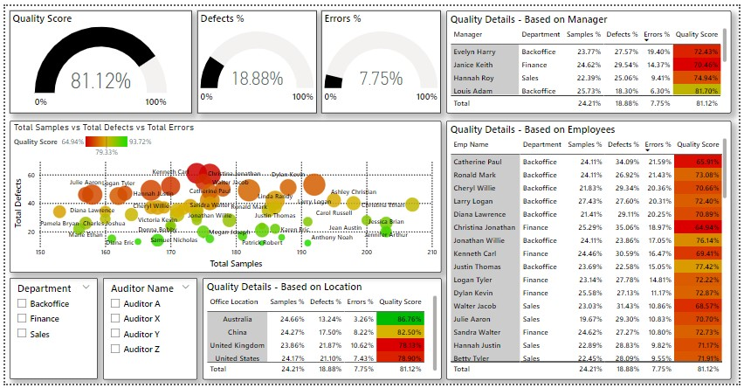

1. Sheet 3 – Overall Analysis

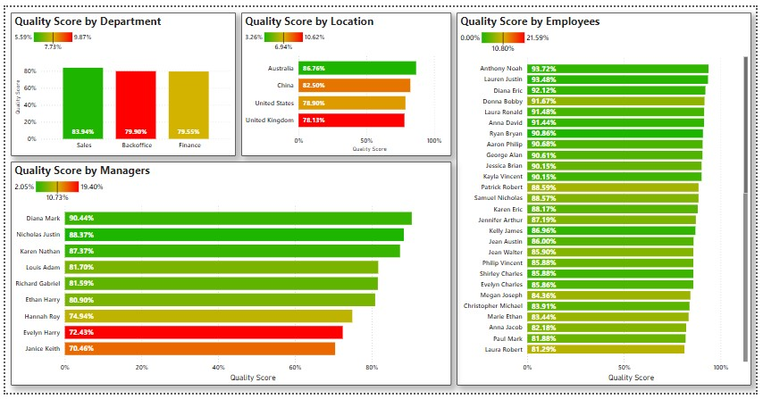

**Analysis of Product Quality Management Project**

The **Product Quality Analysis Project** focuses on ensuring high-quality products and services through systematic quality management. Below is a detailed analysis of the project based on its critical phases:

**Phases of Focus**

**1. Pre-Production: Identifying Consumer Needs**

* **Objective:** Understanding customer expectations and embed them into product design specifications.
* **Analysis:**
  + Conducting surveys, market research, and focus groups to gather consumer needs.
  + Translate consumer feedback into actionable product design specifications, ensuring that design aligns with market demands.
  + Anticipate potential issues based on historical data and competitor analysis to set realistic quality benchmarks.

**2. During Production: Quality Control Across Processes**

* **Objective:** Implement quality assurance at every production stage to meet established quality standards.
* **Analysis:**
  + **Raw Materials:** Inspect material quality before use to prevent defects downstream.
  + **Machinery:** Regularly maintain and calibrate production equipment to ensure consistent performance.
  + **Manpower:** Train workers in quality standards and practices to minimize human errors.
  + **Processes:** Monitor intermediate outputs at various production checkpoints using standardized procedures and tools.
  + **Packaging:** Ensure packaging maintains product integrity and aligns with consumer expectations.

**3. Post-Production: Meeting Design and Quality Specifications**

* **Objective:** Deliver a product that adheres to design specifications and consumer expectations.
* **Analysis:**
  + Conduct rigorous testing to ensure the final product meets the defined quality parameters.
  + Establish a zero-defect goal by leveraging lean manufacturing principles and Six Sigma techniques.
  + Collect feedback from consumers to identify areas for improvement in future production cycles.

**Recommendations for Sustained Quality Improvement**

1. **Adopt Predictive Analytics**: Use historical data to anticipate defects and proactively address quality issues.
2. **Implement Continuous Training Programs**: Regularly update employees on new quality standards and technologies.
3. **Integrate Quality Management Software**: Automate quality monitoring and reporting to enhance accuracy and efficiency.
4. **Focus on Sustainability**: Incorporate eco-friendly practices in raw materials, production, and packaging to appeal to environmentally conscious consumers.